Day in the Life of the Hudson River 10/05/2023
Plum Point, Kowawese, New Windsor, NY
RIVER MILE: 58.1
Salt Front: ~ RM 52
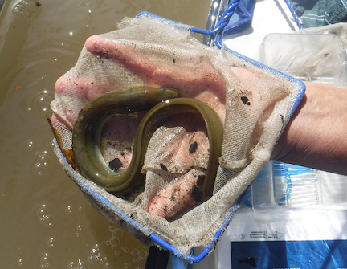
Cornwall Middle School-Charisse Pagano
Orange County Water Authority- Sarah Archbald
50 students, 7th grade, 8 adults
Latitude 41.46176°N & Longitude –74.01194°W
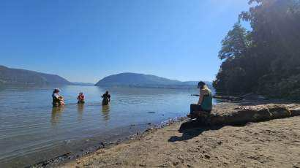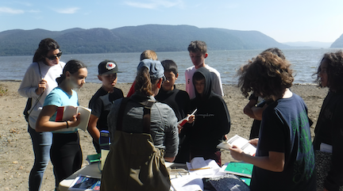

Location: Plum Point, Kowawese, New Windsor, Orange County, NY
Surrounding Land Use: 50% Beach, 45% Forested, 5% Urban/Residential
Sampling Site: Grassy & Forested, Beach, Wood Bulkhead, Area covered in vegetation, RipRap on shoreline, Parking lot
Shoreline: 20% Sandy, 10% Muddy, 70% Rocky
Water: Choppy
River Bottom: Rocky
Plants in the water: 20% Water Chestnuts, 31% Eel Grass
*NR = Not read/recorded

ITEM | Time | Reading |  |  | Comments
Physical
Air Temperature | 10:15 AM  10:56 AM  11:35 AM  12:03 PM  1:00 PM | 26.5°C  26°C  26.5°C  25 º C  25 º C |  | 79°F  79°F  80 º F  78.5 º F  77 º F
Wind Speed: | 9:00 AM  10:18 AM  11:01 AM  11:41 AM  12:07 PM  1:05 PM | Anemometer  18 mph gust  4-9 pmh  5.7 mph  5.4 mph  13.1 mph gust |  | Beaufort  3.5  3  3  3  3 | Direction  SE  SE  S/SE  S  S  S
Weather today | 10:24 AM  11:52 AM  12:02 PM  1:06 PM | 26-50% Cloud Cover  26-50% Cloud Cover  26-50% Cloud Cover  Clear |  | No Rain
Weather the past 3 days: | No Rain in the past 3 days, unseasonable warm conditions for October 5th
Tides- | Time | Rising, Falling, Unchanged |  | Height (cm)
 | 9:25 AM  10:36 AM  11:09 AM  11:38 PM  12:58 PM | -  Falling  Slack  Rising  Rising |  | 0  -110 cm  -102 cm  -35 cm  +24 cm | Set point
Current- | Time | Cm/sec | Knots | North/South | Ebb/Flood/Slack
*Currents were tracked from the shoreline within the small cove formed by the point on the northern Kowawese beach - sheltered from main channel of River. | 10:29 AM  11:08 AM  11:50 AM 12:17 PM  12:54 PM | 2.4  11.3  9.1  5.8  5.13 | 0.02  .2  .18  .11  .1 | (flood – N)  (flood – N) | Flood  Flood  Flood
Water Temperature- | 10:09 AM  10:40 AM  11:17 AM  11:56 AM  12:36 PM | 20°C  20°C  20°C  21°C  20°C |  | 68°F  68°F  68°F  70°F  68°F
Turbidity- Long Sight Tube (120 cm)  (Average of 3 readings per group) | 10:22 AM  11:00 AM  11:44 AM  12:18 PM  1:01 PM | 13.26 cm  14.9 cm  23.6 cm  21.6 cm  24.5 cm |  | 10:22 AM 80 JTU
Chemical

Standardized Salinity- Low Range Quantabs | 12:45 PM | 44 ppm Cl⁻ |  |  | 79 ppm  (Total Salinity -TS)
Student Salinity- Low Range Quantabs | 10:09 AM  10:40 AM  11:17 AM  11:56 AM  12:36 PM | 36 ppm Cl-  NR  40 ppm Cl⁻  36 ppm Cl⁻  34 ppm Cl- |  |  | 65 ppm TS  72 ppm TS  65 ppm TS  61 ppm TS
DO – Hach Drop Count Kit | Time | Temp |  |  | ppm DO | % saturation
 | 10:09 AM  10:40 AM  11:17 AM  11:56 AM  12:36 PM | 20°C  20°C  20°C  21°C  20°C |  |  | 15 ppm  10 ppm  10 ppm  113 ppm  110 ppm | 165%  115%  110%  113%  110%
pH – Color Match Kit | 10:09 AM  10:40 AM  11:17 AM  11:56 AM  12:36 PM | 7.25  7  7.25  7.25  7.5
Biological
Fish- Seine (10 Hauls) | Number | Name |  |  | Length of longest | Smallest
10:00 AM-12:30 PM | 1  7  1  1  1  1  2 | Largemouth Bass  Striped Bass  American Eel  Blueback Herring  White Perch  Channel Catfish  Bay Anchovy |  |  | 10 cm  32 cm  25.4 cm  7.6 cm  10 cm  22.86 cm  10 cm | 10 cm  5 cm
Fish Totals | TOTAL: 14 | Diversity: 7
Macroinvertebrates | Number | Name |  |  | Length of longest
Macroinvertebrate Totals | TOTAL: 0 | Diversity: 0
Sediment Core | Time | Oxid Top | H₂S Smell | Oil | Grain Size | Other Features
10.5 cm  25 cm |  | No  Yes (2.5 cm) | No  No | No  Yes | Common: Clay, Mud & Sand  Rare: Gravel & Pebbles  Abundant: Clay  Common: Mud | Common: Wood

Boats-NR
Commercial/  Recreational | Time | Type | Color | Southbound/  Northbound | Light/  Loaded

