Day in the Life of the Hudson River 10/05/2023
Plum Point, Kowawese, New Windsor, NY
RIVER MILE: 58.1
Salt Front: ~ RM 52
San Miguel Academy -Marianne Serratore, Principal
Mt. St. Mary’s College – Suparna Bhalla
Orange County Water Authority- Sarah Archbald &
Mary Lynne Malone
33 students, 7th grade, 8 undergrads, 4 adults
Latitude 41.46176°N & Longitude –74.01194°W
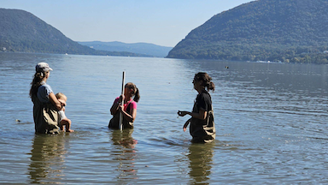
Location: Plum Point, Kowawese, New Windsor, Orange County, NY
Surrounding Land Use: 50% Beach, 45% Forested, 5% Urban/Residential
Sampling Site: Grassy & Forested, Beach, Wood Bulkhead, Area covered in vegetation, RipRap on shoreline, Parking lot
Shoreline: 20% Sandy, 10% Muddy, 70% Rocky
Water: Choppy
River Bottom: Rocky
Plants in the water: 20% Water Chestnuts, 31% Eel Grass
*NR = Not read/recorded

Afternoon session did not turn in data but OCSWD turned in the fishing data for them so that is below.
ITEM | Time | Reading |  |  | Comments
Physical
Air Temperature
Wind Speed: |  | Anemometer |  | Beaufort | Direction
Weather today
Weather the past 3 days:
Tides- | Time | Rising, Falling, Unchanged |  | Height (cm)
Current- | Time | Cm/sec | Knots | North/South | Ebb/Flood/Slack
Water Temperature-
Turbidity-
Chemical

Standardized Salinity- Low Range Quantabs | 12:45 PM | 44 ppm Cl⁻ |  |  | 79 ppm  (Total Salinity -TS)
Student Salinity-
DO – | Time | Temp |  |  | ppm DO | % saturation
pH – Color Match Kit
Biological
Fish- Seine | Number | Name |  |  | Length of longest | Smallest
 | 1  4  21 | Bluegill Sunfish  Spottail Shiner  Herring |  |  | 7.62 cm  20.32 cm  6.35 cm | 6.0 cm  10.16 cm  NA
Fish Totals | TOTAL: 26 | Diversity: 3
Macroinvertebrates | Number | Name |  |  | Length of longest
Macroinvertebrate Totals | TOTAL: 0 | Diversity: 0
Sediment Core | Time | Oxid Top | H₂S Smell | Oil | Grain Size | Other Features

Boats-NR
Commercial/  Recreational | Time | Type | Color | Southbound/  Northbound | Light/  Loaded

