Day in the Life of the Hudson River 10/05/2023
Dennings Point, Beacon, NY
RIVER MILE: 60
Salt Front: ~ 52
Wappingers High School-Steven Birnbaum
Clarkson University’s Beacon Institute for River and Estuaries-Tony Shenderovich & Bridgette Walsh
23 students, 9th-12th grade, 8 adults
Latitude 41.49147°N & Longitude –73.98506°W
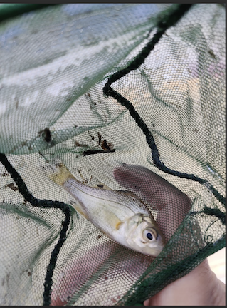 | 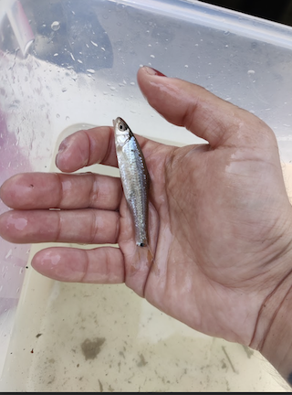 | 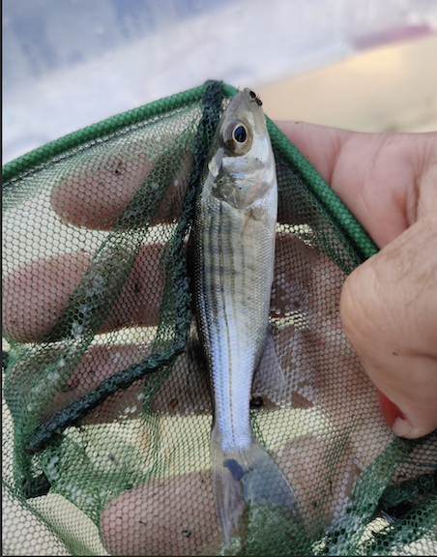
White Perch | Spottail Shiner | Striped Bass

Location: Dennings Point, 200 yards south of Long Dock RD. Parking lot, Beacon, Dutchess County, NY
Surrounding Land Use: Nature preserve with few buildings, 50% Forested, 50% Beach
Sampling Site: Beach, covered with vegetation, rocky & sandy
Shoreline: Rocky & Sandy; Covered with vegetation
Water: Calm
River Bottom: NR
Plants in the water: Water Chestnuts
*NR = Not read/recorded
ITEM | Time | Reading |  |  | Comments
Physical
Air Temperature | 10:06 AM | 19.5 º C |  | 67 º F
Wind Speed: NR |  | Anemometer |  | Beaufort | Direction
Weather today | 10:06 AM | < 25% Cloud Cover |  | No Rain
Weather the past 3 days: | Last 2 days warmer, foggy
Tides- | Time | Rising, Falling, Unchanged |  | Height (cm)
 | 10:06 AM-10:35 AM | Falling |  | 6.3 cm  3.8 cm
Current- NR | Time | Cm/sec | Knots | North/South | Ebb/Flood/Slack
Water Temperature- | 10:10 AM | 22° |  | 72°F
Turbidity- NR
Chemical

Standardized Salinity- Low Range Quantabs | 10:49 AM | 67 ppm
Student Salinity- Hydrometer | 10:10 AM | 6,000 ppm* |  |  | *Most likely an error
DO – Chemets Kit | Time | Temp |  |  | ppm DO | % saturation
 | 12:30 PM |  |  |  | 8-10 ppm
pH – Wide Range pH Kit | 12:30 PM | 7.5
Biological
Fish-Seine (18 Hauls) | Number | Name |  |  | Length of longest | Notes
8:30 AM-12:00 PM | 200  4  6  7  10 | Herring sp.  Spottail Shiner  White Perch  Striped Bass  YOY |  |  | 20.32 cm  7.6 cm
Fish Totals | TOTAL:  227 | Diversity: 5
Macroinvertebrates | Number | Name |  |  | Length of longest
 | 2 | Blue Crab |  |  | 2.5 cm
Macroinvertebrate Totals | TOTAL: 2 | Diversity: 1
Sediment Core -NR | Time | Oxid Top | H₂S Smell | Oil | Grain Size | Other Features

Boats-NR
Commercial/Recreational | Time | Name | Color | Southbound/Northbound | Light/Loaded

