Day in the Life of the Hudson River 10/05/2023
Seeger Riverfront Park, Beacon, NY
RIVER MILE: 61.2
Salt Front: ~ 52
South Avenue Elementary School-Aaron Burke
38 students, 5th grade, 7 adults
Latitude 41.50887°N & Longitude –73.98538°W
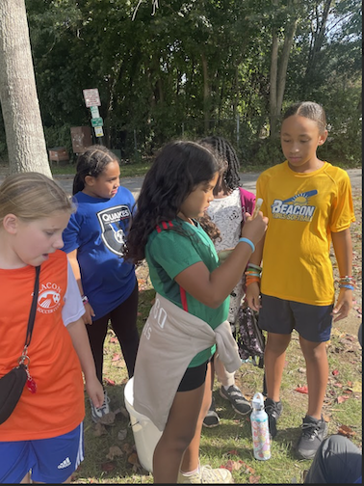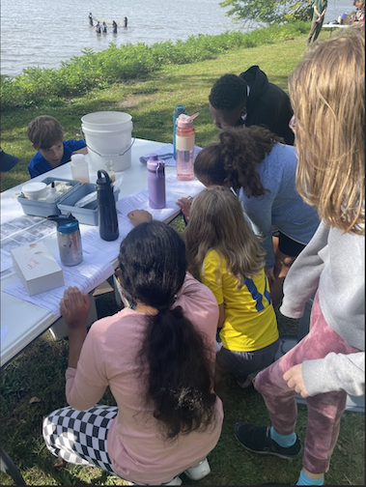
Location: Seeger Riverfront Park, Beacon, Dutchess County, NY
Surrounding Land Use: 100% Urban/Residential
Sampling Site: Beach, covered in vegetation, banks altered, rip rap
Shoreline: Rocky
Water: NR
River Bottom: NR
Plants in the water: NR
*NR = Not read/recorded

ITEM | Time | Reading |  |  | Comments
Physical
Air Temperature | 10:34 AM  10:45 AM  11:09 AM  11:30 AM | 19.5°C  20.6°C  19.5°C  20.6°C |  | 67°F  69°F  67°F  69°F
Wind Speed: | 10:36 AM  10:45 AM  11:11 AM | Anemometer  2.4 m/s  4.03 m/s  3.03 m/s |  | Beaufort  1 | Direction
Weather today | 10:49 AM  11:00 AM | >75% Cloud Cover  51-75% Cloud Cover |  | No Rain  No Rain
Weather the past 3 days: | Cool in AM, Warm in PM, little precipitation
Tides- NR | Time | Rising, Falling, Unchanged |  | Height (cm)
Current- NR | Time | Cm/sec | Knots | North/South | Ebb/Flood/Slack
Water Temperature- NR
Turbidity- NR
Chemical

Standardized Salinity- Low Range Quantabs | 44 ppm Cl- | 79 ppm Total Salinity |  |  | 0.79 ppt - TS | 1.8 LR QT units
DO – Chemets Kit | Time | Temp |  |  | ppm DO | % saturation
 | 11:00 AM | NR |  |  | 7 ppm | 60%
pH – Color Match Kit | 11:00 AM | 7
Nitrates-
Biological
Fish | Number | Name |  |  | Length of longest | Notes
 | 33  5  6  1  1 | Herring sp.  Golden Shiner  White Perch  Striped Bass  Tessellated Darter
Fish Totals | TOTAL: 46 | Diversity: 5
Macroinvertebrates | Number | Name |  |  | Length of longest
Macroinvertebrate Totals | TOTAL: 0 | Diversity: 0
Sediment Core -NR | Time | Oxid Top | H₂S Smell | Oil | Grain Size | Other Features

Boats-NR
Commercial/  Recreational | Time | Name | Color | Southbound/  Northbound | Light/  Loaded

