Day in the Life of the Hudson River 10/05/2023
Long Dock Park, Beacon, NY
RIVER MILE: 61
Salt Front: ~RM 52
NFA P-Tech-Joyce D’Imperio and team
Scenic Hudson-Anthony Coneski and staff
50 students, 9th & 10th grade, 6 adults
Latitude 41.50312°N & Longitude –73.98696°W
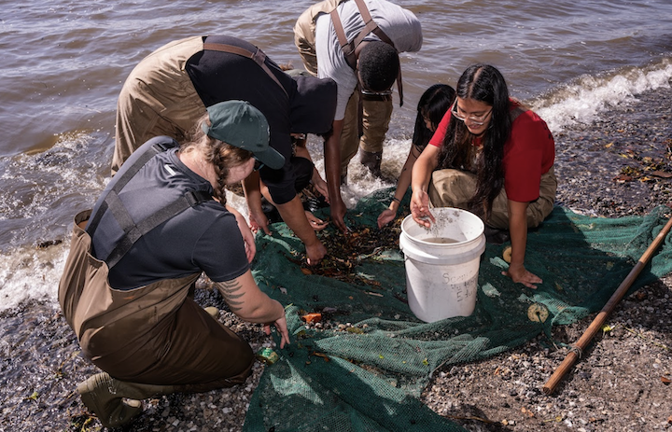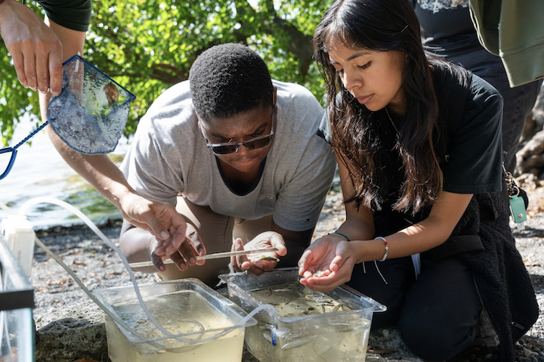
Location: Long Dock Park, Beacon, Dutchess County, NY
Surrounding Land Use: 15% Forested, 5% Urban/Residential, 25% Beach, 5% River Bank
Sampling Site: Public park, pier with kayak launch, grassy and forested areas, wooden bulkhead, marshy, altered banks, parking lot, covered in vegetation
Shoreline: 75% Rocky, 5% Sandy, 20% Muddy
Water: Calm, 61 cm deep
River Bottom: Muddy & Rocky
Plants in the water: No Plants in water
*NR = Not read/recorded
ITEM | Time | Reading |  |  | Comments
Physical
Air Temperature | 10:19 AM  11:10 AM  12:25 PM  12:57 PM | 21°C  22°C  22.8°C  24°C |  | 69.8°F  71.6°F  73°F  75°F
Wind Speed: | 10:22 AM  11:06 AM  12:27 PM  12:57 PM | Anemometer  6.5 mph  11.5 mph  10 mph  8 mph |  | Beaufort  2  3  3  3 | Direction  South  South  Southeast  NR
Weather today | 10:15 AM  11:05 AM  12:28 PM  12:57 PM | 26-50% Cloud Cover  51-75% Cloud Cover  <25% Cloud Cover  <25% Cloud Cover |  | No Rain  No Rain  No Rain  No Rain
Weather the past 3 days: | Windy, warm, dry
Tides- Tide Stick | Time | Rising, Falling, Unchanged |  | Height (cm)
 | 10:58 AM  11:05 AM  12:21 PM | -  Slack  Rising |  | 10 cm  10 cm  18 cm
Current- | Time | Cm/sec | Knots | North/South | Ebb/Flood/Slack
 | 10:38 AM  11:22 AM  11:22 AM  12:40 PM  1:10 PM  1:10 PM | 30.48  26.5  33.94  52  14.38  10.43 |  |  | -  -  -  -  Flood  Flood
Water Temperature- | 10:12 AM  10:22 AM  11:02 AM  12:22 PM  12:42 PM  12:50 PM  12:58 PM  NR | 20°C  15°C  20.5°C  20°C  22°C  19°C  22.5°C  21°C |  | 68°F  60°F  68.9°F  68°F  71°F  66°F  72.5°F  70°F
Turbidity- Long Sight Tube (120 cm) | 11:05 AM  12:52 PM  1:27 PM | 75.2 cm  23 cm  56 cm |  | 91 cm | Secchi Disk (cm)
Chemical

Standardized Salinity- Low Range Quantabs reading #2.2 | 9:05 AM | 60 ppm Cl⁻ |  |  | 108 ppm TS | TS = Total Salinity
Student Salinity- Low Range Quantabs | 10:40 AM  11:25 AM  12:39 PM  12:50 PM  1:20 PM | 30 ppm Cl⁻  30 ppm Cl⁻  30 ppm Cl⁻  42 ppm Cl⁻  77 ppm Cl⁻ |  |  | 54 ppm TS  54 ppm TS  54 ppm TS  76 ppm TS  139 ppm TS
DO – Drop Count Kit | Time | Temp |  |  | ppm DO | % saturation
*Likely an error - Expect air bubble or failure to swirl in solution | 10:17 AM  10:22 AM  11:02 AM  11:30 AM  12:20 PM  12:22 PM  12:22 PM  12:45 PM  12:57 PM  12:58 PM | 20°C  15°C  21°C  21°C  22°C  18°C  22°C  19°C  21°C  21°C |  |  | 15 ppm*  15 ppm*  28 ppm*  30 ppm*  12 ppm  12 ppm  11 ppm  11 ppm  14 ppm*  10 ppm
pH – | Test Strips  10:22 AM  10:43 AM  11:02 AM  11:30 AM  12:22 PM  12:36 PM  12:47 PM  12:58 PM | Test Strips  7.45  7.4  7.8  8.2  7.1  7.2  7  7.5 |  |  | Color Match Kit  11:30 AM  12:36 PM  1:20 PM | Color Match Kit  8  7.2  7.4
Biological
Fish-Seine | Number | Name |  |  | Length of longest | Notes
11:05 AM-1:14 PM | 1  1  49 | American Eel  Striped Bass  Blueback Herring |  |  | 19.5 cm  6.4 cm  8.5 cm
Fish Totals | TOTAL: 51 | Diversity: 3
Macroinvertebrates | Number | Name |  |  | Length of longest
 | 3 | Blue Crab (F) |  |  | 2 cm
Macroinvertebrate Totals | TOTAL: 3 | Diversity: 1
Sediment Core -NR | Time | Oxid Top | H₂S Smell | Oil | Grain Size | Other Features

Boats
Commercial/  Recreational | Time | Type | Color | Southbound/  Northbound | Light/Loaded
Commercial  Commercial  Commercial  Recreational  Recreational | 11:10 AM  11:11 AM  11:14 AM  11:24 AM  12:10 PM | Yacht | White  White  White  White  White | Southbound  Southbound  Northbound  Northbound  Northbound | Light  Light  Light  Light  Light

