Day in the Life of the Hudson River 10/05/2023
Chelsea Yacht Club, Wappinger Falls, NY
RIVER MILE: 65
Salt Front: ~ 52
Wappingers Jr High School-Rosellen Hardt
25 students, 7th grade, 4 adults
Latitude 41.553508°N & Longitude –73.970238°W
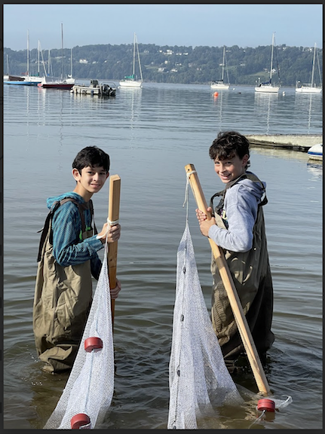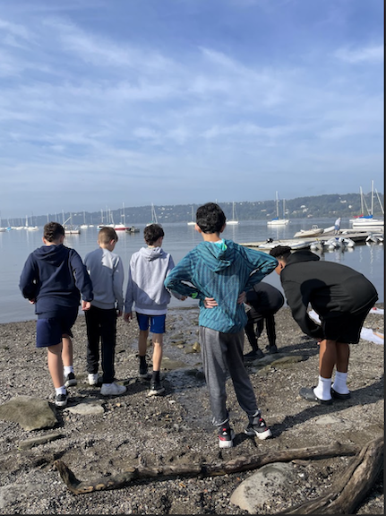
Location: Chelsea Boat Launch, Chelsea Yacht Club, Wappinger Falls, Dutchess County, NY
Surrounding Land Use: 25% Urban/Residential, 40% Industrial/Commercial, 25% Beach
Sampling Site: Pier, Beach, Wood Bulkhead, Grassy, Forested, Covered in vegetation, Rip Rap, Concrete Bulkhead, Marshy
Shoreline: Sandy, Muddy & Rocky
Water: Calm
River Bottom: Weedy, Sandy, Muddy & Rocky
Plants in the water:
*NR = Not read/recorded

ITEM | Time | Reading |  |  | Comments
Physical
Air Temperature-NR |  | º C |  | º F
Wind Speed: NR |  | Anemometer |  | Beaufort | Direction
Weather today |  | <25% Cloud Cover |  | No Rain
Weather the past 3 days: | Warm
Tides- Dock to water | Time | Rising, Falling, Unchanged |  | Height (cm)
 | 9:42 AM  10:10 AM  10:57 AM  11:34 AM  12:42 PM | -  Falling  Falling  Falling  Rising |  | 49 cm  50 cm  54 cm  59.5 cm  40 cm
Current- | Time | Cm/sec | Knots | North/South | Ebb/Flood/Slack
 | 9:56 AM  10:20 AM  11:07 AM  11:42 AM  12:51 PM | 762  457.2  411.48  381  213.36 | 0.49  0.30  0.27  0.25  0.14 |  | Ebb
Water Temperature- | 9:39 AM  10:11 AM  10:54 AM  11:00 AM  11:31 AM  12:37 PM | 20°C  19.5°C  19.6°C  19°C  20.1°C  21.2°C |  | 68°F  67.1°F  67.3°F  66.2°F  68.2°F  70.2°F
Turbidity- long site tube | 9:39 AM  10:11 AM  10:54 AM  11:31 AM  12:37 PM | 55.77 cm  49.8 cm  54.8 cm  53.47 cm  74.2 cm
Chemical

Standardized Salinity- Low Range Quantabs- | No time recorded | 30 ppm Cl⁻ |  |  | 54 ppm  total salinity | 1.4 QT units
DO – Hach Drop Count Kit | Time | Temp |  |  | ppm DO | % saturation
 | 10:53 AM  11:38 AM  12:40 PM | 19.6°C  19°C  19.5°C |  |  | 5 ppm  10 ppm  13 ppm | 55%  105%  140%
pH – Color Match Kit | 9:39 AM  9:41 AM  9:44 AM  10:12 AM  10:18 AM  10:20 AM  10:52 AM  10:55 AM  11:00 AM  11:34 AM  11:39 AM  11:40 AM  12:39 PM  NR | 6.5  6.5  6.5  7  7  7  8  7.5  7  6.5  6.5  6  6.5  7 (X2 readings)
Nitrates-
Biological
Fish | Number | Name |  |  | Length of longest | Length smallest
9:45 AM-12:45 PM | 257  2  3  7  2  1  1 | Herring sp.  Pumpkinseed  White Perch  Mummichog:1M,3F, 2NR  Striped Bass  Spottail Shiner  Largemouth Bass |  |  | 7 cm  11 cm  15 cm  8 cm  11 cm  7 cm  12 cm | 3 cm  9 cm  10 cm  6 cm  NR  NA  NA
Fish Totals | TOTAL:  273 | Diversity: 7
Macroinvertebrates | Number | Name |  |  | Length of longest
 | 8 | Blue Crab (7 M & 1 Unidentified) |  |  | 10 cm | Blue Crab was Softshell
Macroinvertebrate Totals | TOTAL: 8 | Diversity: 1
Sediment Core -NR | Time | Oxid Top | H₂S Smell | Oil | Grain Size | Other Features

Boats
Commercial/  Recreational | Time | Type | Color | Southbound/  Northbound | Light/  Loaded
Recreational  Recreational  Recreational  Recreational  Recreational  Recreational | 9:49  11:42  12:44  10:23  11:04  12:44 | NR  Sailboat  Sailboat  Sailboat  Sailboat  Sailboat | White, Blue & Red  Red, Blue, White & Green  White  White & Blue  White, Green & Red  Blue & White | Northbound  Southbound  Northbound  Northbound  Southbound  Southbound | Light  Light  Light  Light  Light  Light

