Day in the Life of the Hudson River 10/05/2023
Mid-Hudson Discovery Children’s Museum, Poughkeepsie, NY
RIVER MILE: 76.4
Salt Front: ~ 52
Haviland Middle School-Christen Chamberlain
NYSDEC-Rebecca Houser, I Fish New York team
110 students, 7th grade, 14 adults
Latitude N & Longitude –W
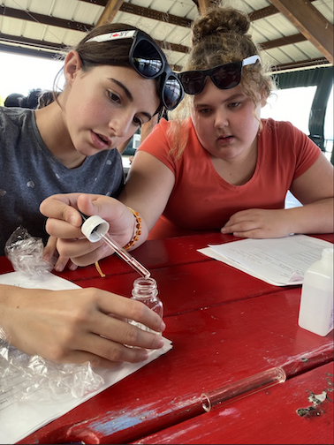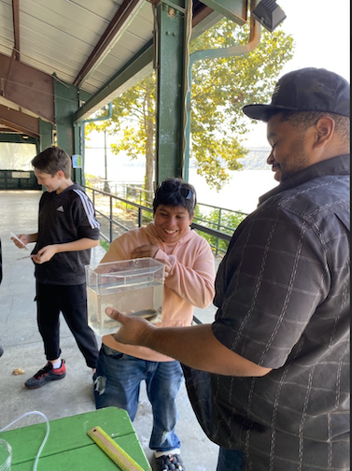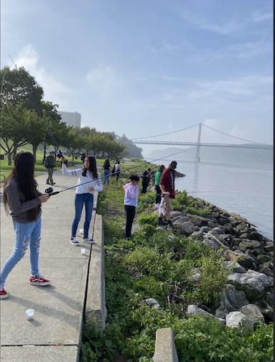
Location: Mid-Hudson Discovery Museum, Poughkeepsie, NY
Surrounding Land Use: 100% Urban/Residential
Sampling Site: Adjacent to the Mid-Hudson Discovery Museum, along the shores of the Hudson and Fallkill creek. A pier with a concrete bulkhead, banks altered, rip raps, grassy area, parking lot adjacent.
Shoreline: 75% Rocky & 25% Muddy
Water: Calm
River Bottom: Muddy & Rocky
Plants in the water: No Plants in the water
*NR = Not read/recorded
ITEM | Time | Reading |  |  | Comments
Physical
Air Temperature | 9:25 AM  10:20 AM  12:12 PM  1:12 PM | 17.8°C  20 º C  23.9°C  25.2°C |  | 64°F  68º F  74°F  77.3°F
Wind Speed: | 9:20 AM  10:20 AM  12:12 PM  1:12 PM  1:44 PM | Anemometer  1.72 mph  2.41 mph  3.7 mph  2.2 mph  3.1 mph |  | Beaufort  1 | Direction  South
Weather today | 9:30 AM  12:30 PM | >75% Cloud Cover  < 25% Cloud Cover |  | No Rain  No Rain
Weather the past 3 days: | NR
Tides- Tide Stick | Time | Rising, Falling, Unchanged |  | Height (cm)
 | 9:10 AM  10:00 AM  11:00 AM  12:00 PM  12:45 PM  1:55 PM  2:27 PM | Falling  Falling  Falling  Slack  Rising  Rising  Rising
Current- | Time | Cm/sec | Knots | North/South | Ebb/Flood/Slack
*Orange Came Back | 9:15 AM  10:00 AM  12:10 PM  1:04 PM*  2:20 PM |  |  |  | Flood  Flood  Slack  -  Flood
Water Temperature- | 9:30 AM  10:35 AM  1:09 PM | 18°C  18°C  20°C |  | 64.4°F  64.4°F  68°F
Turbidity- Long Sight Tube (120 cm) | 10:15 AM  1:30 PM | 41 cm  55 cm
Chemical

Standardized Salinity- Low Range Quantabs – 1.2 QT units | 8:20 AM | Below Detection
Student Salinity- Low Range Quantabs – 1.6 QT units | 12:30 PM | 39 ppm Cl⁻ |  |  | 70 ppm Total Salinity
DO – Hach Drop Count Kit | Time | Temp |  |  | ppm DO | % saturation
 | 9:06 AM  12:30 PM | 18°C  19°C |  |  | 9 ppm  10 ppm | 95%  105%
pH – Color Match Kit | 9:30 AM  10:30 AM  12:30 PM  1:00 PM | 7.5  7  7.5  8
Biological
Fish- Seining (8 Hauls) & Rod and Reel | Number | Name |  |  | Length of longest | Notes
 | 2  1  1  2  1  1 | American Eel  Channel Catfish  Banded Killifish  White Perch  Smallmouth Bass  Black Crappie |  |  | 21 cm  32 cm
Fish Totals | TOTAL: 8 | Diversity: 6
Macroinvertebrates | Number | Name |  |  | Length of longest
Macroinvertebrate Totals | TOTAL: 0 | Diversity: 0
Sediment Core -NR | Time | Oxid Top | H₂S Smell | Oil | Grain Size | Other Features

Boats- NR
Commercial/Recreational | Time | Name | Color | Southbound/  Northbound | Light/Loaded

