Day in the Life of the Hudson River 10/05/2023
Quiet Cove Park, Poughkeepsie, NY
RIVER MILE: 78
Salt Front: ~ RM 52
Krieger Elementary School-Skip Hoover
Cornell Cooperative Extension-Anna Harrod-McGrew
DEC Fisheries - Bobby Adams and team
98 students, 5th grade, 25 adults
Latitude 41.73506°N & Longitude –73.93632°W
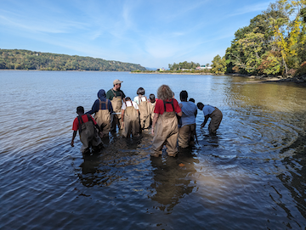 | 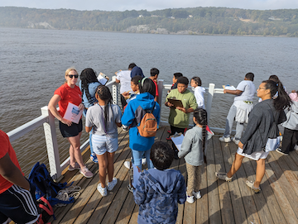 | 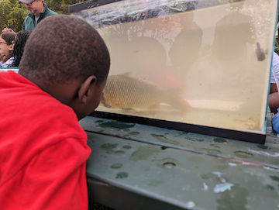

Location: Quiet Cove, Poughkeepsie, Dutchess County, NY. East side of the Hudson River.
Surrounding Land Use: Picnics, boating and fishing—60% is beach with rip rap banks, 40% previous industrial site
Sampling Site: An old industrial area that has been turned into a park. Used by people for picnics, fishing.
Shoreline: Rocky, altered banks with rip rap and wooden bulkhead, boat launch for kayaks and canoes.
Water : NR
River Bottom: NR
Plants in the water: NR
*NR = Not read/recorded
ITEM | Time | Reading |  |  | Comments
Physical
Air Temperature | 10:32 AM | 17.7 º C |  | 64 º F
Wind Speed: | 10:32 AM | Anemometer |  | Beaufort  2 | Direction  South
Weather today | 10:32 AM | Low clouds with heavy fog |  | No Rain
Weather the past 3 days: | Foggy mornings with very warm sunny afternoons
Tides- | Time | Rising, Falling, Unchanged |  | Height (cm)
 | 10:15 AM-12:57 PM | Rising |  | 305 cm  330 cm
Current- | Time | Cm/sec | Knots | North/South | Ebb/Flood/Slack
 |  | 8.62 |  | South | Ebb
Water Temperature- | 10:45 AM | 23°C
Turbidity- Short Sight Tube (60 cm) | 11:05 AM | 55 cm  50 cm  27 cm
Chemical

Standardized Salinity- Low Range Quantabs | 1:45 PM | Below Detection
DO – Lamotte Elementary Science Test Tablet Kit | Time | Temp |  |  | ppm DO | % saturation
 | 10:45 AM | 23°C |  |  | 4 ppm
pH – Color Match Kit | 10:45 AM | 8
Nitrates- Lamotte Elementary Science Water Test Kit | 10:45 AM | < 5ppm
Phosphates- Lamotte Elementary Science Water Test Kit | 10:45 AM | 2 ppm
Biological
Fish-Electroshocking on site | Number | Name |  |  | Length of longest | Notes
9:30 AM-1:15 PM | 1  2  1  1  3 | Common Carp  American Eel  Redbreast Sunfish  Largemouth Bass  Tessellated Darter |  |  | 40 cm  48 cm  17 cm  11 cm  7 cm
Fish Totals | TOTAL: 8 | Diversity: 5
Macroinvertebrates | Number | Name |  |  | Length of longest
Macroinvertebrate Totals | TOTAL: 0 | Diversity: 0
Sediment Core | Time | Oxid Top | H₂S Smell | Oil | Grain Size | Other Features
 |  |  | Yes | No | Common: Mud, Sand  Rare: Clay, Gravel | Common: Brick

Boats-NR
Commercial/Recreational | Time | Name | Color | Southbound/Northbound | Light/Loaded

