Day in the Life of the Hudson River 10/05/2023
Norrie Point, Staatsburg, NY
RIVER MILE: 84.5
Salt Front: ~ RM 52
Poughkeepsie High School-Nicole Vilardi
F.D. Roosevelt High School- Glen Burger
Bard College- Caroline Ramaley
NYSDEC- Maija Niemisto
33 students, 11th-12th grade, 8 adults
Latitude 41.83242°N & Longitude –73.94129°W
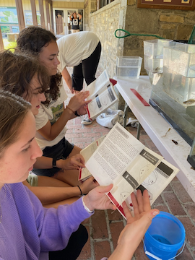 | 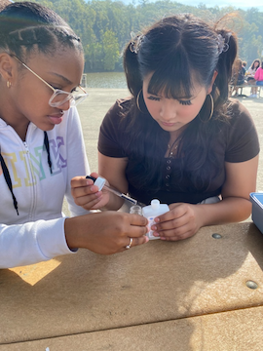 | 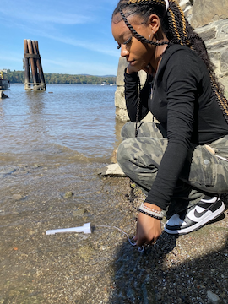

Location: Norrie Cove and Southwest corner of Norrie Point Environmental Center Patio, Norrie Point, Staatsburg, Dutchess County, NY.
Surrounding Land Use: 90% Forested & 10% Parking lot & environmental center
Sampling Site: Front banks altered, rip rap. Cove is very muddy with some riprap and west side is rocky. Beach area, shore with bulkhead, shoreline rip rap, banks altered for building, riprap along RR tracks, collected wood and debris in shallow cove, pipe entering river area.
Shoreline: Muddy & Rocky
Water: Calm
River Bottom: Muddy
Plants in the water: No Plants in the water, water chestnuts gone!
*NR = Not read/recorded

ITEM | Time | Reading |  |  | Comments
Physical
Air Temperature | 10:19 AM  11:10 AM  12:56 PM | 25 º C  27 º C  24 º C |  | 77 º F  81°F  75°F
Wind Speed: | 11:10 AM | Anemometer  0.9 m/s |  | Beaufort  1 | Direction  Southeast
Weather today | 11:00 AM | 26-50% Cloud Cover |  | No Rain
Weather the past 3 days: | Rainy
Tides- Tide Stick | Time | Rising, Falling, Unchanged |  | Height (cm)
 | 10:19 AM  11:10 AM  12:30 PM  12:56 PM | -  Falling  Falling  Rising |  | 25.5 cm  15.25 cm  12.75 cm  17.75 cm
Current- | Time | Cm/sec | Knots | North/South | Ebb/Flood/Slack
 | 10:19 AM  11:10 AM  12:30 PM  12:56 PM |  |  |  | Ebb  Ebb  Slack  Flood
Water Temperature- | 10:19 AM  11:04 AM  12:25 PM | 20°C  20°C  21°C |  | 68°F  68°F  69.8°F | *Taken at 2 ft water depth
Turbidity- Long Sight Tube (120 cm) | 10:19 AM  11:04 AM  12:30 PM | 41 cm  36 cm  22 cm
Chemical

Standardized Salinity-Low Range Quantabs | 1:30 PM | Below Detection
Student Salinity- Hydrometer | 10:19 AM  11:05 AM  12:25 PM | 0 ppt  0 ppt  0 ppt
DO – Hach Drop Count Kit | Time | Temp |  |  | ppm DO | % saturation
 | 10:19 AM  11:04 AM  12:30 PM | 20  20  21 |  |  | 8 ppm  8 ppm  9 ppm | 98%  100%  100%
pH – Color Match Kit | 10:19 AM  11:04 AM  12:25 PM | 7.6  7.5  7.5
Biological
Fish- Seine (5 Hauls) | Number | Name |  |  | Length of longest | Notes
10:00 AM-1:00 PM | 2  72  77  2  2  5  1  5  10  11  1  2  8 | Alewife  American Shad  Atlantic Menhaden  Rudd  Banded Killifish  White Perch  Striped Bass  Sunfish sp.  Pumpkinseed  Bluegill  Smallmouth Bass  Largemouth Bass  Tessellated Darter |  |  | 7.4 cm  15 cm  15.24 cm  9.6 cm  6.9 cm  10.15 cm  12.7 cm  4.1 cm  12.75 cm  10.15 cm  10.15 cm  8.6 cm  6.6 cm | 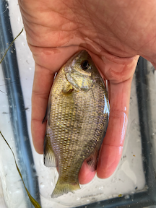  Rudd
Fish Totals | TOTAL:  198 | Diversity: 13
Macroinvertebrates | Number | Name |  |  | Length of longest
 | 12 | Blue Crab |  |  | 6 cm
Macroinvertebrate Totals | TOTAL: 12 | Diversity: 1
Sediment Core | Time | Oxid Top | H₂S Smell | Oil | Grain Size | Other Features
19.04 cm | 11:04 AM | No | No | No | Abundant: Mud  Common: Sand  Rare: Gravel | Abundant: Living vegetation  Common: Leaves  Rare: Wood, Macroinvertebrates

Boats
Commercial/Recreational | Time | Type | Color | Southbound/Northbound | Light/Loaded
Recreational  Recreational  Recreational  Recreational  Recreational  Recreational  Recreational  Recreational  Recreational  Recreational  Recreational | 10:16  10:26  10:41  10:41  10:43  10:48  11:26  12:34  12:34  1:13  1:22 | Kayak  Sailboat  Sailboat  Sailboat  Kayak  Sailboat  Sailboat  Powerboat  Powerboat  Jetski  Speed Boat | Orange  White  Blue  White  Red  -  White  -  Blue  Black | Northbound  Northbound  Southbound  Southbound  Southbound  Northbound  Northbound  Northbound  Southbound  Northbound  Northbound

