Day in the Life of the Hudson River 10/05/2023
Kingston Point Park, Kingston, NY
RIVER MILE: 92
Salt Front: ~ RM 52
Kingston High School-Jason Prizzi
Kingston Parks and Recreation- KC Keegan-Twombly
30 students, 12th grade, 6 adults
Latitude 41.930213°N & Longitude –73.964668°W
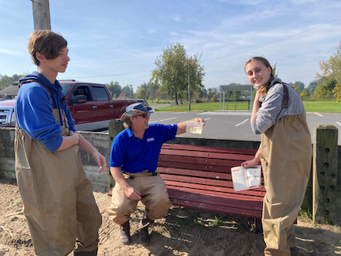
Location: Swimming Beach Kingston Point, City of Kingston, Ulster County, NY.
Surrounding Land Use: 5% Forested, 10% Industrial/Commercial & 85% Beach
Sampling Site: Beach shoreline sandy, brick pieces, banks are altered, collected wood debris in the area, rip rap to north along brickyard shoreline. Sandy shoreline 75 ft from shoreline to parking lot, 200 ft wide with boat launch large amount of brick debris from prior industry.
Shoreline: 100% Sandy
Water: NR
River Bottom: Sandy
Plants in the water: No Plants in the water
*NR = Not read/recorded
ITEM | Time | Reading |  |  | Comments
Physical
Air Temperature | 10:39 AM  12:25 PM | 21 º C  22 º C |  | 69 º F  71.6 º F
Wind Speed: | 9:26 AM | Anemometer |  | Beaufort  1 | Direction  East
Weather today | 10:30 AM | <25% Cloud Cover |  | No Rain
Weather the past 3 days: | Warm, no rain, unseasonably warm
Tides- NR | Time | Rising, Falling, Unchanged |  | Height (cm)
Current- NR | Time | Cm/sec | Knots | North/South | Ebb/Flood/Slack
Water Temperature- | 9:25 AM  10:45 AM  12:10 PM | 22°C  22°C  19°C |  | 71.6°F  71.6°F  66.2°F
Turbidity- Secchi Disk (cm) | 9:37 AM  10:48 AM | 20 cm  40 cm
Chemical

Standardized Salinity- Low Range Quantabs | 11:25 AM | 30 ppm Cl- |  |  | 54 ppm total salinity | 1.4 quantab units
DO – Lamotte Drop Count Kit | Time | Temp |  |  | ppm DO | % saturation
 | 12:31 PM | 29°C |  |  | 4 ppm | 27%
pH – Color Match Kit | 9:27 AM  10:30 AM  12:20 PM | 8.3  8  7.5
Nitrates- Nitrate Tabs | 9:47 AM | 0 mg/L
Phosphates- Color Match Test Kit | 9:28 AM | 1 mg/L
Biological
Fish-Seine (6 Hauls) | Number | Name |  |  | Length of longest | Notes
9:30 AM-12:15 PM | 9  15  1  35 | Spottail Shiner  Banded Killifish  White Perch  Striped Bass |  |  | 12.7 cm  12.5 cm
Fish Totals | TOTAL: 60 | Diversity: 4
Macroinvertebrates | Number | Name |  |  | Length of longest
 | 2 | Mud Crabs
Macroinvertebrate Totals | TOTAL: 2 | Diversity: 1
Sediment Core | Time | Oxid Top | H₂S Smell | Oil | Grain Size | Other Features
 | 11:30 AM | No | No | No | Common: clay, mud, sand | Common: brick

Boats-NR
Commercial/Recreational | Time | Name | Color | Southbound/Northbound | Light/Loaded

