Day in the Life of the Hudson River 10/05/2023
Sojourner Truth/Ulster Landing Park, Ulster County NY
RIVER MILE: 97
Salt Front: ~ RM 52
Red Hook High School-Tom O’Dowd
Cary Institute - Becky Van Tassell
35 students, 9th-12th grade, 5 adults
Latitude 42.00425°N & Longitude –73.94467°W
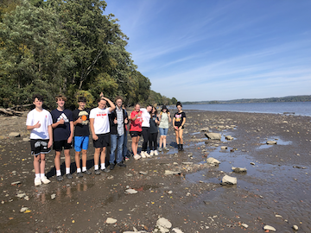 | 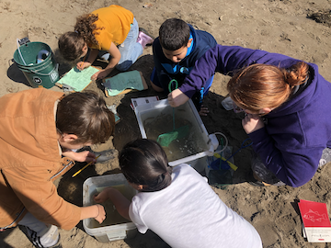 | 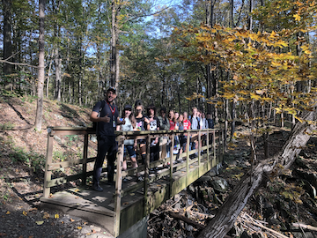

Location: Swimming beach, Sojourner Truth/Ulster Landing Park, Town of Ulster, Ulster County, NY
Surrounding Land Use: 50% Forested & 50% Beach
Sampling Site: Beach, altered banks with concrete bulkhead, wood debris driftwood, drainage from bulkhead north of site, nearby parking lot, grassy area.
Shoreline: 50% Sandy, 40% Muddy & 10% Rocky
Water: Calm
River Bottom: Muddy, Sandy & Rocky
Plants in the water: 1% Water Chestnuts (far away from shore)
*NR = Not read/recorded

ITEM | Time | Reading |  |  | Comments
Physical
Air Temperature | 12:00 PM | 22.2 º C |  | 72 º F
Wind Speed: | 11:33 AM  12:01 PM  12:12 PM | Anemometer  3.34 mph  6.84 mph  2.68 mph |  | Beaufort | Direction  South  Southeast  South
Weather today | 11:33 AM  2:01 PM | <25% Cloud Cover  26-50% Cloud Cover |  | No Rain  No Rain
Weather the past 3 days: | A bit cooler but nice
Tides- Tide Stick | Time | Rising, Falling, Unchanged |  | Height (cm)
 | 10:45 AM  12:30 PM  1:30 PM | -  Falling  Rising |  | 51 cm  25 cm  28 cm
Current- | Time | Cm/sec | Knots | North/South | Ebb/Flood/Slack
 | 10:45 AM  12:30 PM | 8.47  8.47
Water Temperature- | 11:33 AM | 20 °C |  | 68°F
Turbidity- Long Sight Tube (120 cm) | 11:43 AM | 28 cm
Chemical

Standardized Salinity- Low Range Quantabs | 12:05 PM | Below Detection
Student Salinity-Low Range Quantabs | 11:53 AM | 31 ppm Cl⁻ |  |  | 56 ppm Total Salinity
DO – Hach Drop Count Kit | Time | Temp |  |  | ppm DO | % saturation
 | 11:43 AM  12:22 PM | 20 °C  NR |  |  | 7 ppm  8 ppm
pH – Color Match Kit | 12:10 PM | 7
Biological
Fish-Seine | Number | Name |  |  | Length of longest | Notes
 | 50  50  1  7  27  3  1  2 | YOY Herring spp.  Spottail Shiner  White Catfish  Banded Killifish  White Perch  Striped Bass  Pumpkinseed  Tessellated Darter
Fish Totals | TOTAL:  141 | Diversity: 8
Macroinvertebrates | Number | Name |  |  | Length of longest
 | 5 | Blue Crab |  |  |  | 1 male blue crab was dead
Macroinvertebrate Totals | TOTAL: 5 | Diversity: 1
Sediment Core - NR | Time | Oxid Top | H₂S Smell | Oil | Grain Size | Other Features

Boats
Commercial/Recreational | Time | Type | Color | Southbound/ Northbound | Light/Loaded
Recreational  Recreational  Recreational  Recreational | 12:54 PM  10:00 AM  12:30 PM  10:45 AM | Speed Boat  Sailboat  Motor Boat  Jet ski | Black & Red  White  White  White/Red | Southbound  Northbound  Southbound  Doing Circles

