DAY IN THE LIFE OF THE HUDSON & HARBOR
10/14/21 DATA COLLECTION SHEET
VIDEO LINK
NAME:

Travel through the estuary and collect data from three different sites: Sherman Creek in the salty harbor area, Piermont Pier in the brackish (a mix of fresh and salty water) lower estuary, and Norrie Point further north in the freshwater section. All three are part of the Hudson Estuary and are tied together by one driving force. To learn more about this you will want to watch the short accompanying video by our guest scientist Laurel Zaima. But first, let’s explore the estuary!

Use this sheet to record your data and then answer the questions on page #2. For the fish ID after using the Clearwater fish key http://fishkey.clearwater.org enter the species name and an X in the box for the location where it was collected.
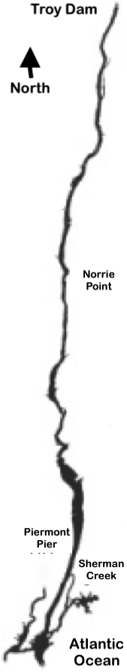 |  | Units | Sherman Creek | Piermont Pier |  | Norrie Point
 | WATER TEMP. | °C/°F
 | DISSOLVED OXYGEN | ppm
 | TURBIDITY (CLARITY) | cm
 | SALINITY | ppt
 |  | Species Name |  |  | Sherman Creek | Piermont Pier | Norrie Point
 | FISH & OTHER ANIMALS

Introductory Questions:

Who Lives Where:

Migration!
1) Two of the fish species that were introduced are migratory species. Both are found throughout the Hudson estuary. Although they are both migratory, their migration patterns are exactly opposite each other, one lives in the ocean most of its life and comes into the Hudson to spawn, the other does the opposite. Can you identify the two species and which one has which lifestyle?

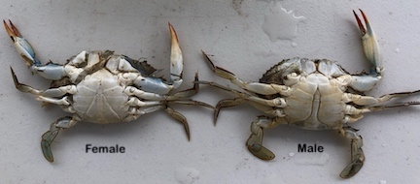
Blue Crab: 2) We see a blue crab in the video. We can tell the sex of a blue crab by looking at its belly, even in this younger crab. A male looks like a Washington Monument and the female is more rounded. Did we catch a male or a female?

Fish have salt tolerances:
3) Fish have tolerances that tell us where they CAN be found and preferences that tell us where they PREFER to be found.
- Using the list of fish you entered and where they were caught add the salinity from where they were caught beside their name.
- Answer and explain, does this show their salinity tolerance or their preference?

TAKING A DEEPER DIVE!
For Middle School and High School students

Spatial Trends, Relationships & Stories
A phenomenon is an observable fact or trend! In Day in the Life we examine a variety of phenomenon and often it changes between sites. Spatial Trends in our data would be a variation in the phenomenon we are looking at (water temperature, dissolved oxygen, turbidity, salinity) that shows an increasing or decreasing shift as you move from North to South or South to North.

Look at each phenomenon to see if you find a spatial trend
4) What do you see in your data? Looking at the items listed below is there a clear trend in any of them moving from North to South or South to North?
- Water Temperature
- Dissolved Oxygen (D.O.)
- Turbidity
- Salinity

5) Can you explain what might be causing the trend(s) that you found?

Relationships:
6) We learned that water temperature is related to D.O. levels in the estuary. Looking at the data you collected, describe the relationship you see between the two?

7) Remember the healthy range of D.O. is between 5-11ppm. Looking at the relationship of water temperature and D.O. is colder or warmer water better for high oxygen levels?

A Story in the Data:
8) The turbidity doesn’t seem to have any story to tell, but actually it does! Even though Sherman Creek is really muddy it is less turbid than Piermont! That might seem odd, but there are two interesting things to think about with Piermont.
(a) Remember the water was really active at Piermont. This can stir up anything in the water making it more turbid.
(b) Piermont is located in an area of high mixing for fresh and salt water in the estuary. This high mix area catches up anything in the water and cycles it around creating a place in the river called “The Turbidity Maximum Zone”. Your data shows it!
(c) Finally let’s think about Norrie Point and how clear the water was at Norrie compared to the other sites. Remember how calm the water surface was, and recall that this area was fresh water so there was no mixing. Both of these conditions caused the water to be very clear, over three times clearer at Norrie Point than at Piermont!

Fish Story:
9) At our first stop we caught a mummichog, a type of killifish. Over the whole estuary on Day in the Life we caught three different types of killifish. Where we found them tells a story about these species preferences for habitat and water conditions. You can learn more about this in our website under Lessons: Is the Hudson a River or an Estuary: High School / Middle School

LET’S TAKE AN EVEN DEEPER DIVE!
Guest Scientist VIDEO

Guest Scientist Bonus Questions!
10) In her deep dive our Guest Scientist introduced the unifying parameter that ties together all the pieces of our Hudson River Estuary - tides! She then examines a unique phenomenon that occurred just after Day in the Life.

- Are tides introduced to the estuary from the North or the South?
- The phenomenon our Guest Scientist introduced was from a type of storm she called a Nor’ Easter. Is this impact from this phenomenon introduced to the estuary from the North or the South?

- For sites that do seining during the Day in the Life event some locations are able to seine at Low Tide and others are able to seine at High Tide. Sherman Creek is a location where a High Tide is better, yet Piermont Pier is a location where High Tides can be difficult to impossible to seine in. If we had scheduled the Day in the Life event on October 28th would either of these two sites have been able to seine, and if so which one?

- When you look across the full set of tidal data shown in the graph, is the biggest effect on the High Tides or the Low Tides?

Why do you think that is?

