Use separate sheet for each seine OR note what was caught in each seine by noting seine #. TIME________________
Fish Species: # of individuals: Size of largest (unit)
1. ____________________________ ____________ ___________ ____
2. ____________________________ ____________ ___________ ____
3. ____________________________ ____________ ___________ ____
4. ____________________________ ____________ ___________ ____
5. ____________________________ ____________ ___________ ____
6. ____________________________ ____________ ___________ ____
7. ____________________________ ____________ ___________ ____
8. ____________________________ ____________ ___________ ____
9. ____________________________ ____________ ___________ ____
10. ____________________________ ____________ ___________ ____
11. ____________________________ ____________ ___________ ____
12. ____________________________ ____________ ___________ ____
Pumpkinseed Sunfish
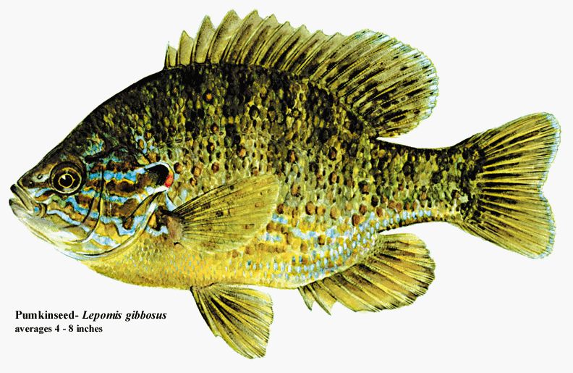
Macroinvertebrates:
1. ____________________________
2. ____________________________
3. ____________________________
4. ____________________________
Tessellated Darter
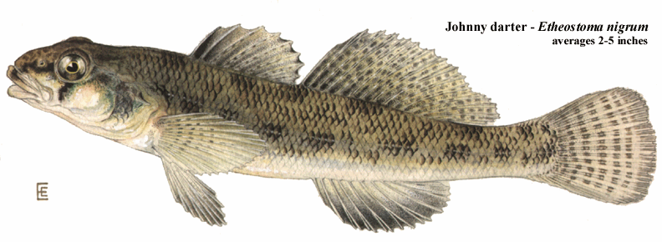

5. ____________________________
6. ____________________________
7. ____________________________
8. ____________________________
Atlantic Silverside
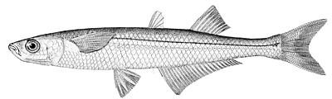
9. ____________________________
10. ____________________________

