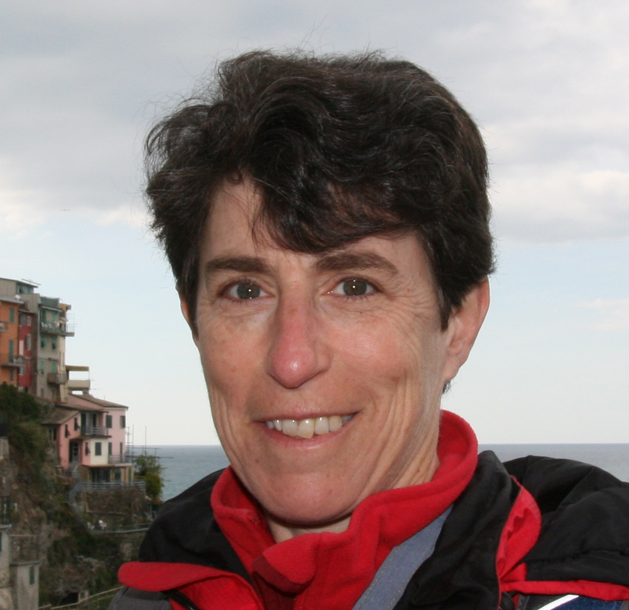
Ellen S. Kappel
Geo Prose
5610 Gloster Rd.
Bethesda, MD 20816
ekappel@geo-prose.com
https://geo-prose.com
301-229-2709

Dr. Kappel graduated from Cornell University in 1980 with a bachelor’s degree in geology. Her undergraduate thesis was on seismicity in the Sunda Arc. Although she started out in the seismology group at Lamont, midway through her graduate work she was invited on a research cruise by Bill Ryan, and was hooked. Subsequently, she went on another six cruises as a grad student, most of which had nothing to do with her thesis research on the Juan de Fuca Ridge, but she sure got a lot of great seagoing experience. She received her PhD from Columbia/Lamont in 1985.

After a nine-month stint as a Postdoctoral Research Scientist at Lamont, and more cruises, Dr. Kappel decided to “take a break” from research and become a program manager for the Ocean Drilling Program at Joint Oceanographic Institutions in Washington, DC. She found that she loved program management, felt as if this was the best way for her to contribute to the ocean sciences community, and never went back to academia. After nearly 12 years at JOI, Dr. Kappel became an accidental entrepreneur, starting Geosciences Professional Services Inc. (Geo Prose). Nearly 20 years later, she’s still a bit perplexed that this niche business is still going strong. She is also Editor, Oceanography magazine.

