Planet Earth In-class Activity
Distribution of Solar Energy Influx in Time and Space
Observations, Interpretations, and Predictions

In “The Sun, Giver of Life,” you learned about solar energy as it originates in the sun’s core and travels to the Earth. In this activity we will explore how that energy is distributed at the surface of the earth, in both space and time. This strategy, of exploring how some parameter of interest varies in space and time, is a common strategy in Earth and environmental science.

In this activity, we will also be practicing making observations from Earth data, and interpreting this data. It is very important in this activity, and indeed in any scientific effort, to keep your observations separate from your interpretations.

Observations are things that you can see (or feel or hear or smell or taste), either with your own senses, or with the aid of instruments, electromechanical sensors, or other tools.
Observations are statements about how the Earth is, or what the Earth does, or what the Earth has (or what the Earth was or did or had at some previous time in its history.) Observations are often answers to the questions: Who? What? When? Where?

Interpretations are statements that seek to explain something about observations. Most often, interpretations seek to answer the question “why?”, to explain the cause of the observed phenomenon. Why did X happen? Why did X happen before Y? Why does X happen only when Y is true?

When scientists think that they have a valid interpretation of why something happens the way it does, a common next step is to make a prediction of what would be observed under different conditions. A powerful interpretation in science is an interpretation that leads to predictions that can be tested by making additional observations.

The data sets we will be working with in this activity come from Black Rock Forest, an education and research forest located just north of West Point. The forest is instrumented with a network of environmental sensors, which collect data about the atmosphere, soil, streamflow, solar energy input and other parameters that are important for the plants and animals which live in the forest.
Part 1: (Hourly solar energy influx data)

This graph shows the total solar radiation, across all wavelengths, received at one of the environmental monitoring stations in the Black Rock Forest. Each data point represents the rate at which solar energy arrives at the earth’s surface, averaged across one hour of data collection. The units are W/m². Remember that a Watt (W) is a measure of the rate of arrival or consumption of energy. One watt equals one joule/second.

Four days worth of data are shown. The days were selected to be days without significant cloud cover.
- Based on this data, write down three observations about the rate of arrival of solar energy onto Black Rock Forest, and how that rate of energy influx varies with time.

B. Write an interpretation for each of your observations. (Continue on the back.)
- Based on your interpretation in part 1-B, predict what the solar radiation versus time of day curve would look like for Black Rock Forest on a sunny day in December. Predict what the solar radiation versus time of day curve would look like on a sunny day in August. On the graph below, sketch your predictions. Be sure to add the symbols for your two new curves onto the graph key.

D. Black Rock Forest is located at 41°N latitude. Based on your interpretation in part 1-B, predict what the solar radiation versus time of day curve would look like on a sunny day at each of the following times and places:
• mid to late September, at 41° S latitude
• mid to late September, at the equator
• mid November, at 60°N latitude
For each of your predictions, sketch a curve on the graph below. Use a distinctive symbol or color for each curve, and add the new symbol or color to the graph key.

Part 2: (Daily average solar radiation data)

A. What is actually measured in Black Rock Forest is an instantaneous measure of the rate of arrival of solar energy per unit area (W/m²). These instantaneous measurements can be averaged across 24 hours to calculate an average daily rate of solar energy influx. Using the data provided below, calculate the average rate of solar influx for one example day.

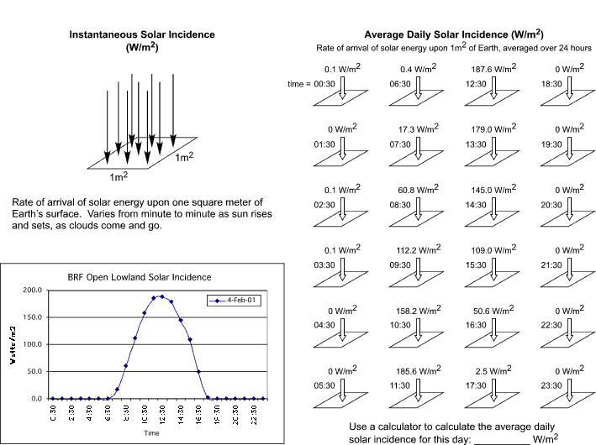
B. The graph below shows the average daily solar radiation received at the same site in Black Rock Forest as the hourly data observed in Part 1 of the activity. This site is in an open meadow away from any trees.

Each data point represents the average of one day’s solar radiation data, just like the average that you hand-calculated on the previous page. Julian Day (horizontal axis) means days elapsed since the beginning of the calendar year.
C. Based on the graph above, write down three observations about the rate of arrival of solar energy onto Black Rock Forest, and how it varies over time.

D. Write an interpretation of your observations (continue on back of this sheet).
E. Black Rock Forest is at 41°N latitude. Based on your interpretation in part 2-D, predict what the same kind of data set would look like collected at 70°N latitude. Superimpose a sketch of your prediction on top of the Black Rock Forest data in the graph below:

