EESC 2200, Fall 2008
Homework 4 due Wed Nov 5

A. Consider the stream hydrograph shown below, together with the hypothetical relationship between discharge, d (in cfs), and velocity, v (in cm/s): v = 17(d/200)^{2/3} and the Hjulstrom curve (reproduced below). Make a graph showing the size particles that can be transported and eroded for the five-year period covered by the hydrograph. Note 1: Don't just use the yearly averages – select at least four points per year off the hydrograph (including the min and max values for that year). Note 2. Think carefully about the best way to display your results! Note 3: Use the version of the Hjulstrom curve shown below, only. Note 4: In past years, some students have been bothered by the formula, above, that converts d to v, because the units don’t seem to match. Just use it and don’t worry. The constant 17 having must have units of cm/s and the constant 200 must have units of cfs. By the way, it’s just a cooked-up formula, so don’t use it outside this problem set.

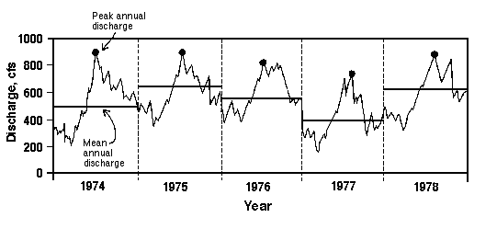
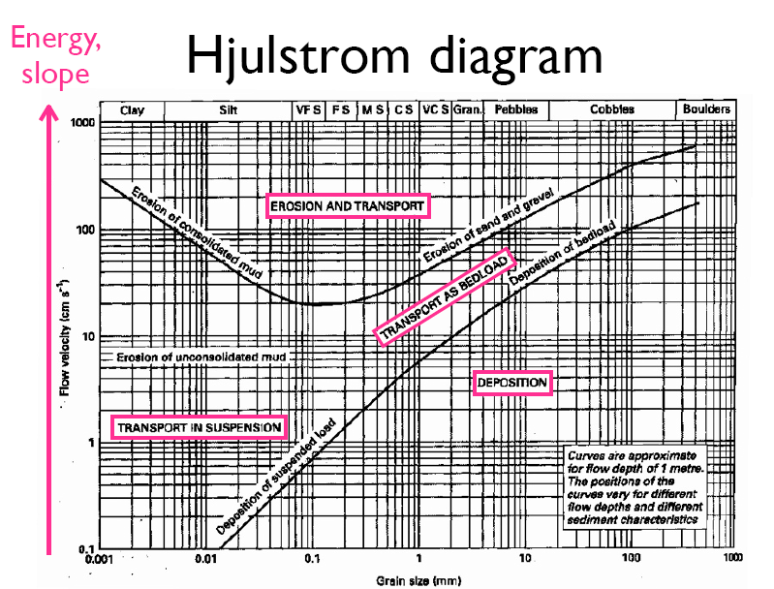
B. B. Imagine that two cubes of rock, Cube A and Cube B, each 1000 meters on edge, are buried just up to their top surfaces in the ground, which is made of rock C. Rock C erodes at 40 meters per thousand years; rock A, 20; and rock B, 10. At the same time, the whole landscape is uplifted at a rate of 40 meters per thousand years. Draw the topography on graph paper at times 0, 25000, 50000, 75000, 100000, 125000 and 150000 years. (It’s best to draw a sequence of separate topographic profiles, one for each time period, with the three rock types shaded or colored differently). You may assume that material is eroded only from the top surfaces (i.e. ignore erosion from the sides of the cubes). Hint 1: Remember that the cubes have bottoms, and that the material beneath them is made of rock C. Hint 2. It might help if you do each time interval in two steps: an uplift step, in which everything is rises uniformly, and an erosion step, where material is stripped off of the surface of each rock according to its erosion rate.

