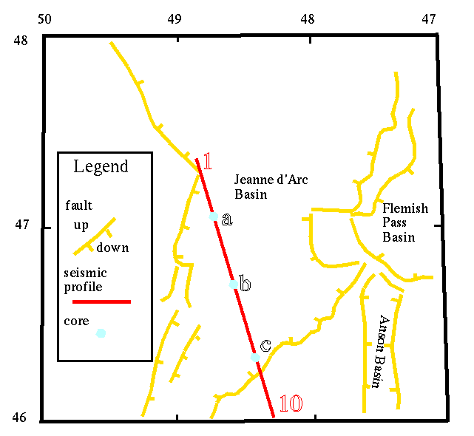
Basin Map. The Jeanne d'Arc Basin (Grand Banks, Canada) is bounded by normal faults (yellow). In this lab we will use data from a seismic profile (red line) and several cores (blue).

