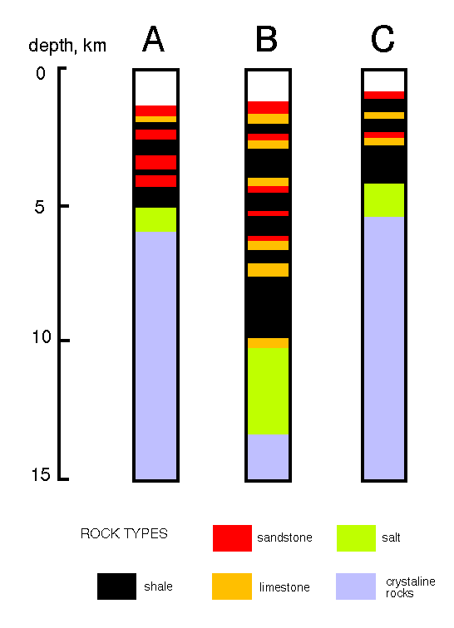
Core Lithologies. Lithological (rock type) data for three cores in the Jeanne d'Arc Basin. (Note: These data are highly schematic and simplified, and do not reresent real cores).

