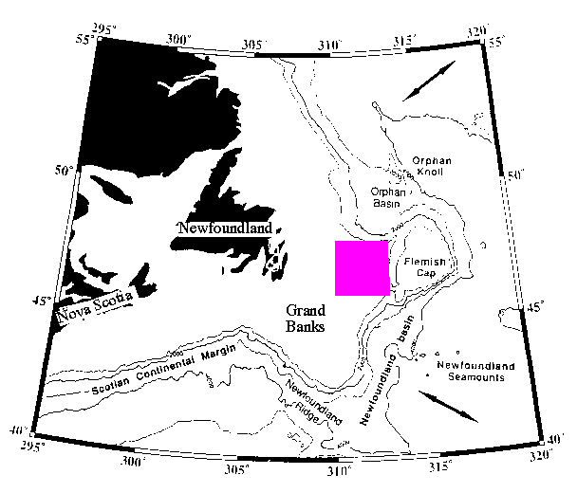
Regional Map of the Grand Banks (Canada). The oil-bearing basin that will be studied in this lab is in the colored rectangle.

