Rift Basin Tutorial
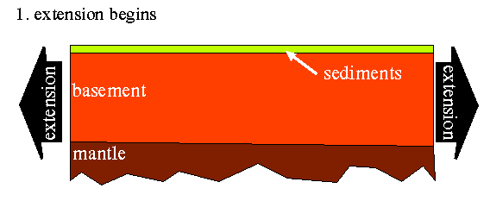
A rift basin forms when the earth's lithosphere is stretched - by plate tectonic forces, for instance - and begins to thin.
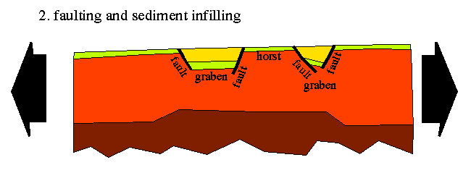
The lower part of the earth can deform plastically like putty, but the upper part is brittle and develops faults. The extension causes a sequence of downthrown blocks (grabens) separated by ridges (horsts) to form. The floors of the grabsens subside slowly, over a period of tens of millions of years, allowing sediments to fill in the low-lying areas.
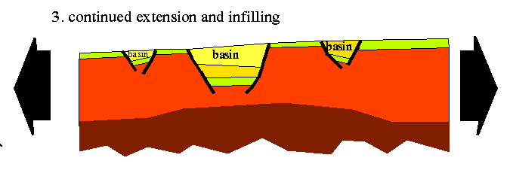
The resulting sedimentary basins can be several kilometers deep.

